FINAL REPORT — 7COM1079 TEAM PROJECT

1. Introduction

Problem Statement & Research Motivation

Knowledge of global demographic trends is critical in healthcare, social care as well as long-term population planning. Ageing countries can have more mortality rates because the older age groups are more vulnerable to mortality. The median age is one of the most common measures of ageing of the population, and death rate indicates the general trends in population mortality. Exploring the relationship between these indicators assists the policymakers to comprehend the existence of systematically higher mortality among ageing populations. According to previous research, demographic ageing is one of the causes of high health burden and risk of mortality (United Nations, 2022). This paper thus investigates the question of the relationship between higher median age in 2021 and higher death rate in countries.

Dataset Description

The data is a collection of world demographic measures of the 202 countries, such as population, fertility rate, life expectancy, median age, birth rate and death rate of 2002 and 2021. In this project we target Median Age (2021) and Death Rate (2021) in order to determine whether older populations have higher mortality. The dataset is in a form of the country being a row, and all the variables are taken as a number; this enables the right statistical and graphical analysis using the R program.

Research Question
Is there a statistically significant correlation between Median Age (2021) and Death Rate (2021) across countries?

Null and Alternative Hypotheses
H0 (Null Hypothesis):
There is no correlation between Median Age (2021) and Death Rate (2021). Any observed relationship in the dataset is due to random variation.
H1 (Alternative Hypothesis):
There is a significant correlation between Median Age (2021) and Death Rate (2021). Higher median age is associated with higher mortality, reflecting demographic ageing patterns.
The hypotheses are suitable because both variables are continuous numerical measures, enabling a Pearson correlation test.

2. Background Research

Research Papers

Demographic ageing has been found to be a significant determinant of the mortality rates in nations as indicated by previous studies. According to Bloom et al. (2015), those countries that become older age structures are more likely to have more deaths as they are age vulnerable. On the same note, Lee and Mason (2014) believe that the changes in population age structure put the healthcare systems under strain and increases the rate of death among the ageing populations. Another study by Dowd et al. (2020) involving cross-country analysis of the demographics also indicates that older median age is significantly linked with a higher likelihood of being at risk in a case of a public health crisis, which supports the idea that median age is a key predictor of population vulnerability.

Whereas the literature is uniform in supporting the correlation between ageing and mortality, not many studies have compared longitudinal demographic variables as those found in this dataset. The data presented in this project offers a certain chance to assess the tendencies of the ageing process on the background of the recent (2021) information and define whether the correlation between the ageing process and mortality is still stable in different areas and income brackets. Thus, the study is based on the evidence that has been established previously but it adds new information with revised global demographic statistics.

Why the RQ Is of Interest

The research question is applicable as the ageing of the population the world over is growing at an alarming rate, and nearly all nations are experiencing a growing need of health care system, pension pressures and challenges in terms of state spending. The knowledge of statistical relationship between higher median age and higher mortality assists in proving the theory of demographic-health and base future planning. According to the existing research, ageing is a major cause of mortality, yet 2021 data (after COVID) suggests new information. The small yet significant gap in the research is addressed by this project as it confirms the presence of the age-mortality relationship in modern data and geographically different countries.

3. Visualisation

Main Plot Explanation

The scatterplot was employed since the two variables, Median Age (2021) and the Death Rate (2021) are continuous. The plot visualises the existence of positive or negative relationship between countries. It was supplemented with a linear regression line to follow the trend better.

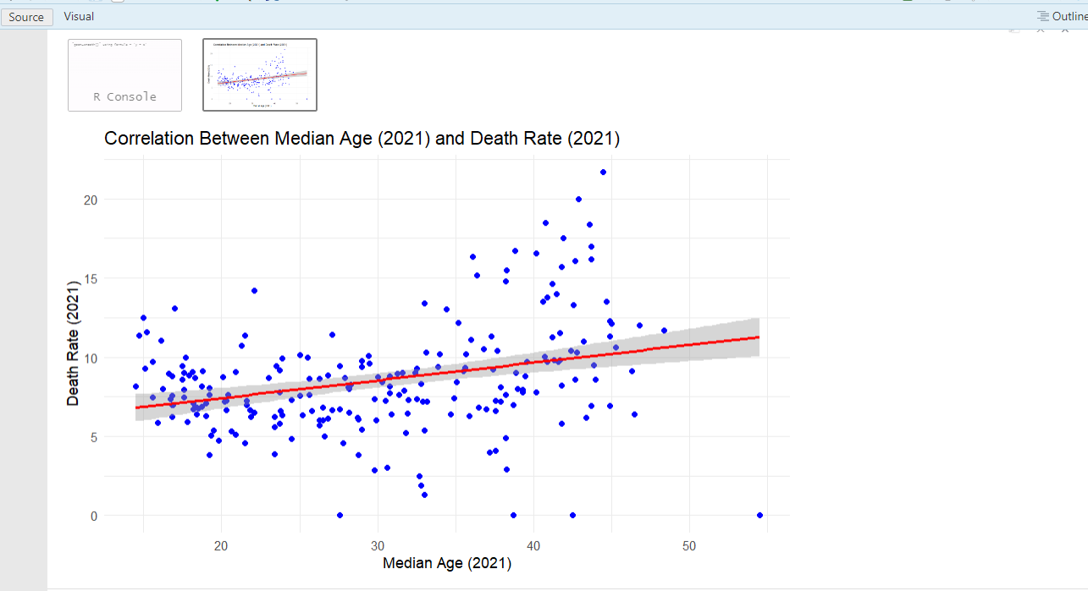

Histogram Explanation
A histogram of Median Age (2021) assists one to find out how ages are distributed in the countries. It enables us to determine the accuracy of the data whether it is normally distributed, skewed or has outliers and therefore, whether it is appropriate to use Pearson correlation.
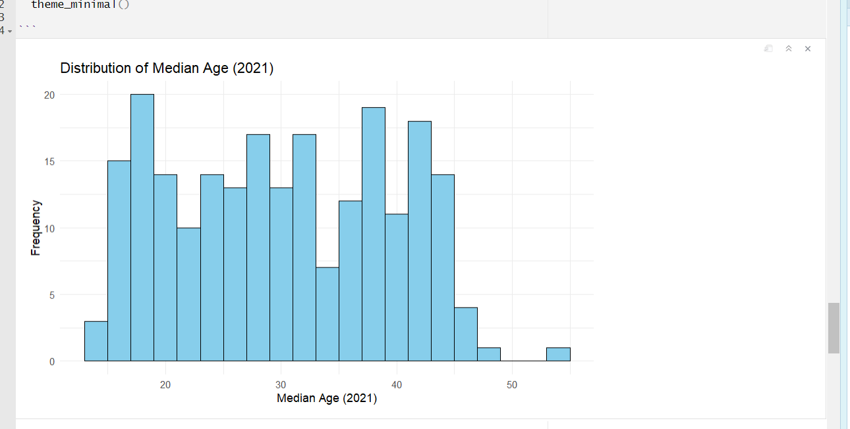

Useful Information for Data Understanding

The scatterplot indicates that an upward trend can be observed, which means that the median age correlates positively with death rate. The histogram shows that median age is a very disparate variable among countries with both ageing population and the young population. The given patterns are reason to conduct some additional statistical tests.

4. Analysis

Statistical Test Used

The test was carried out using Pearson correlation due to the fact that both variables are continuous and they have a relatively normal distribution. Pearson test is used to determine the existence of a linear relationship between the two variables. Also, simple linear regression model was performed to enhance the interpretation by approximating by which percentage the rate of deaths is changing with one unit increase in median age.

Hypothesis Test Result & Interpretation

Pearson correlation test gave:

cor = 0.303, p-value = 3.94e-06, which shows that it is statistically significant and positive. As p is less than 0.05, we reject the null hypothesis. The higher the median age of the countries, the more they are likely to have a higher death rate in 2021.

The regression model also proved to be significant ( = 0.112, p < 0.001) indicating that with increase in median age (1 year) the death rate is raised by approximately 0.11 units. Therefore, the mortality rates among the ageing populations are high among the populations of the world.

5. Evaluation – Group Experience

What Went Well

The team worked as a team in the gathering of literature, R code executions, and the results interpretations. All of the members worked on different parts of the report, and R Markdown analysis workflow served to provide consistency. This visualisation and statistical testing were completed successfully, and the team was enabled to maintain an order in files with the help of GitHub.

Points for Improvement
The further cooperation may be enhanced with the help of planning more regular meetings to check in on each other to make sure that the work is evenly distributed. The members needed more instructions on how to write R Markdown, and it took more time to edit. Setting proper deadlines before would also alleviate pressure at the last minute.

Group Time Management

The team was quite efficient with the data cleaning and visualisation being completed early. The team was not able to keep time, so there were some delays at the stage of the literature review, but the team managed to overcome this issue and work effectively during the last week.

Project Overall Judgement
The project was successful and all the learning outcomes were met. The team were given practical exposure to R, statistical tests, data visualisation and in group report writing. The results were consistent with the theory of demographics.

GitHub Log Output Commentary
All R scripts and plots and the final report were stored in the GitHub repository. Three of the important commits were dataset upload, updating analysis code and overall report integration. Such commits indicate an iterative development and version-following on the files during the project.

Group Contributions (Add names later)
- Student 1: Vinitha Suresh: R code development & data cleaning
- Student 2: Navyasree Dommithi: Visualisation (scatterplot & histogram)
- Student 3: Vivek pisharathparambil Velayudhan : Literature review writing
- Student 4: RanjithReddy Pandhiri: Hypothesis testing & results interpretation
- Student 5: Muhammad Anas: Final report editing & GitHub upload

6. Conclusions

Results Explained

Statistically, it was found that median age and the death rate across countries showed a positive correlation. This implies that countries with an old population are likely to have high mortality rates. This conclusion was enhanced by the regression model which measured the relationship.

Interpretation

Statistically, it was found that median age and the death rate across countries showed a positive correlation. This implies that countries with an old population are likely to have high mortality rates. This conclusion was enhanced by the regression model which measured the relationship.

Future Work & Limitations

Future research may further enhance the analysis by incorporating life expectancy, healthcare expenditure, or the level of income in a region. Its limitations are the lack of values in some countries and using two only demographic variables. Multivariate modelling would provide more insight into the determinants of mortality.

Reference List
Bloom, D., Canning, D. & Fink, G., 2015. Population Aging and Economic Growth. Journal of Economic Perspectives.
Dowd, J. et al., 2020. Demographic Science Aids Understanding of COVID-19 Fatalities. PNAS.
Lee, R. & Mason, A., 2014. Is Low Fertility Really a Problem? Science.
United Nations, 2022. World Population Prospects 2022. UN Department of Economic Affairs.

Appendices

Appendix A – R Code Used
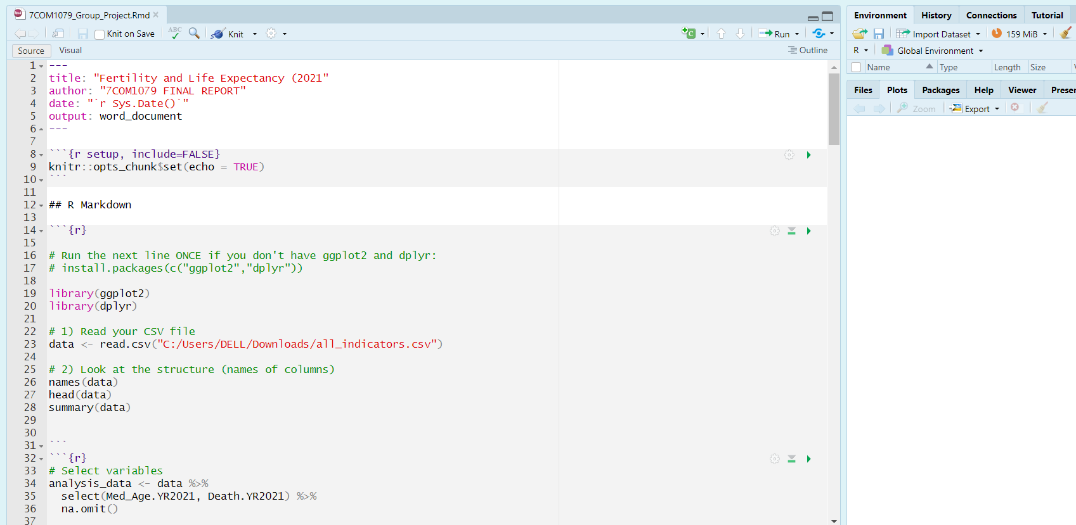

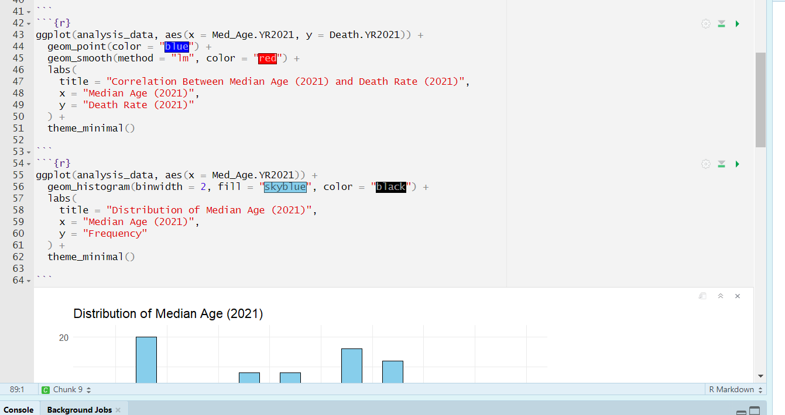

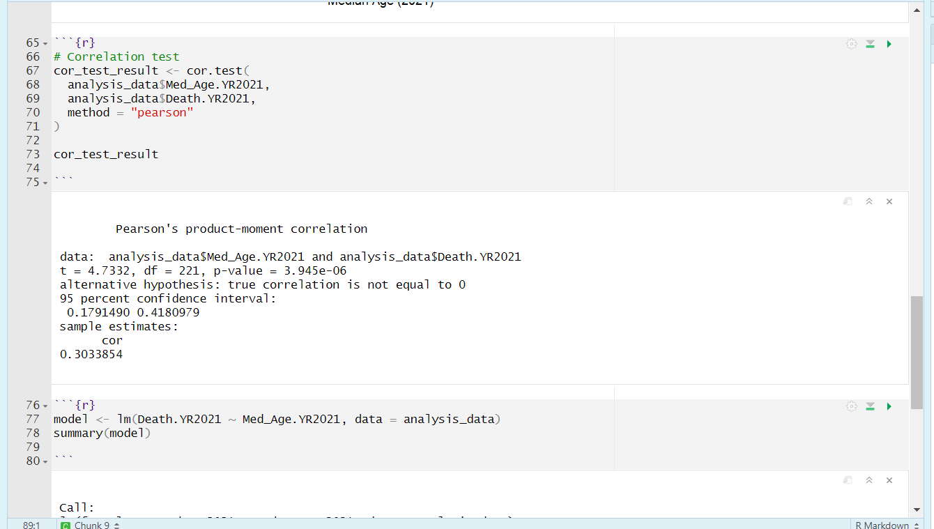

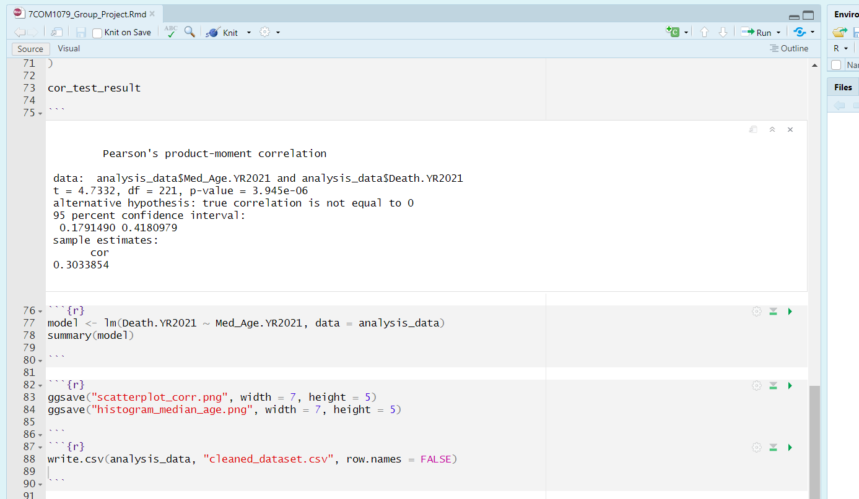

Appendix B – GitHub Log Output
https://github.com/Vinitha1210-cmyk/Team-Research-7COM1079.git

